Stock Price Prediction

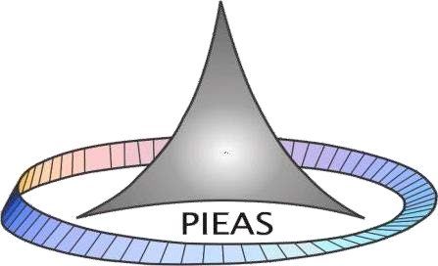

# Submitted to:

Dr Aneela Zameer

# Submitted by:

**Group:**

Aniq Javed Usman Asad Ahmed Raza

**Pakistan Institute of Engineering and Applied Sciences (PIEAS)**

1

## Implementation of Single LSTM layer Model:

2

## Model:

We have trained and tested our model on four stocks that are Apple, Google, Microsoft, Amazon. We have set batch size to 64 and epochs were 10 and window size of 100.

## 

## AAPL:

## Dataset

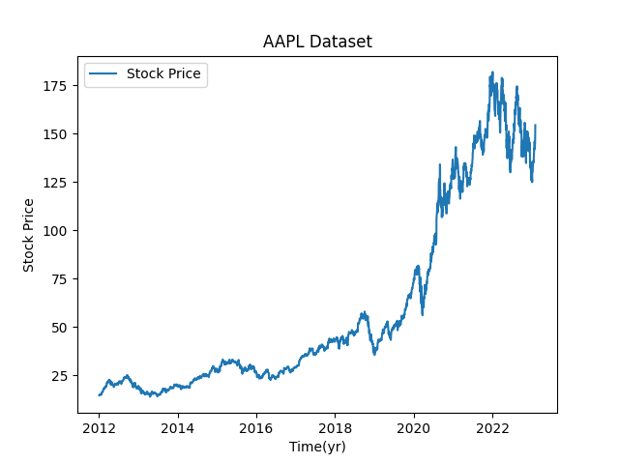

## Train, test and prediction

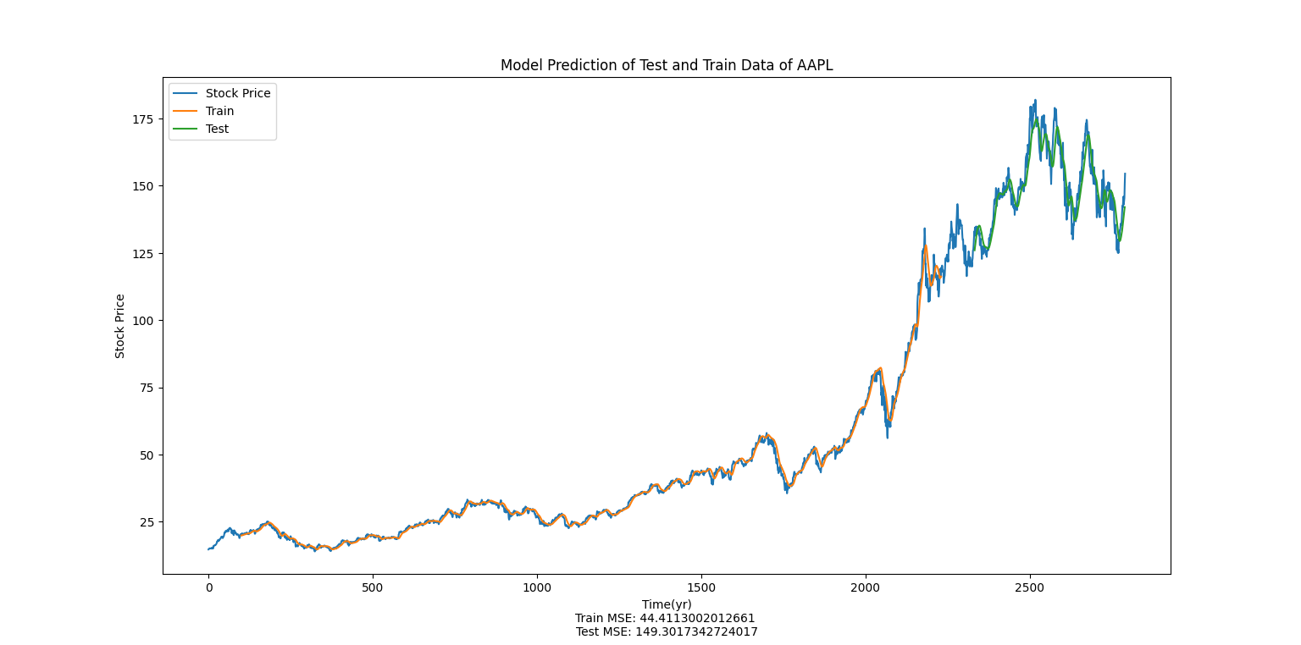

## GOOG:

## Dataset

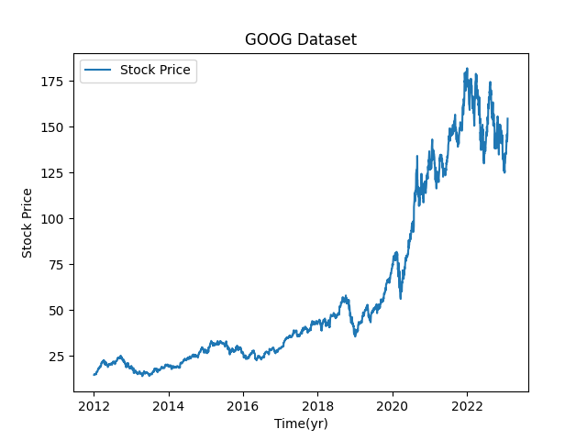

## Train, test and predicition

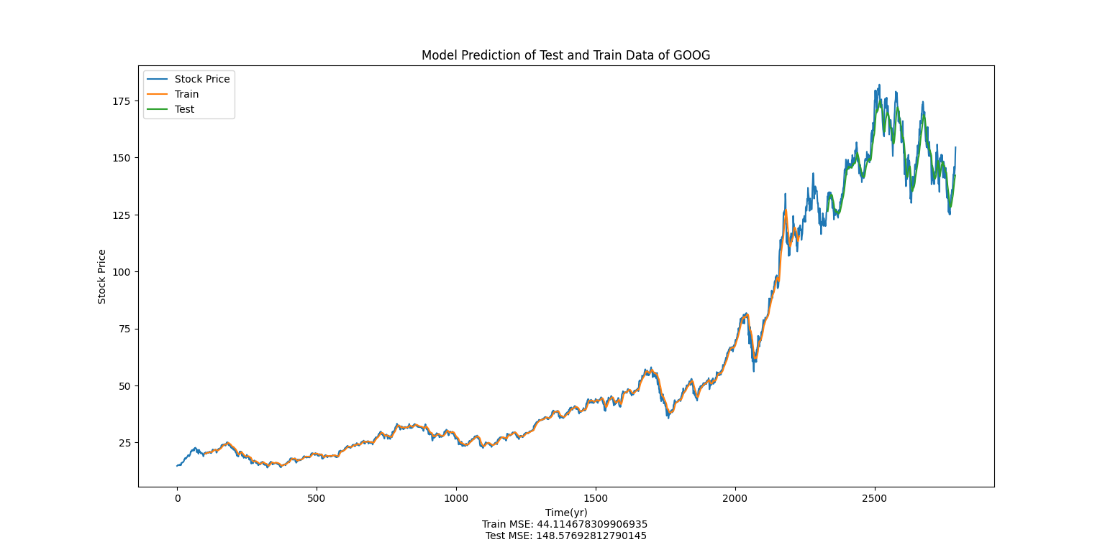

## AMZN:

## Dataset

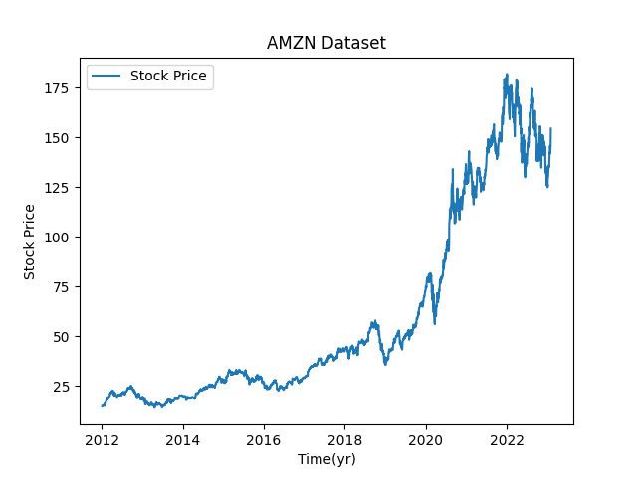

## Train, test and prediction

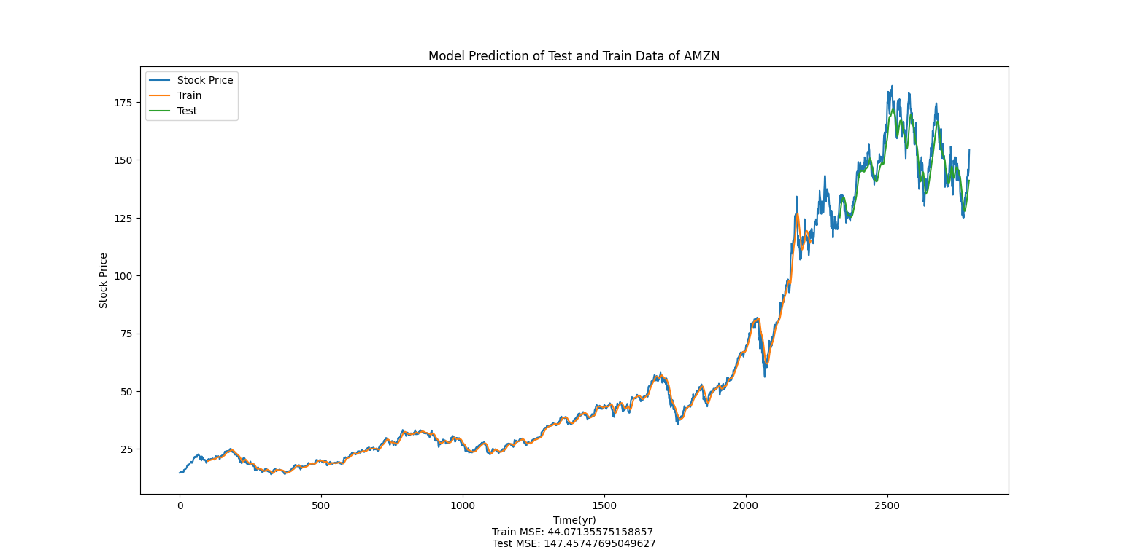

## MSFT:

## Dataset

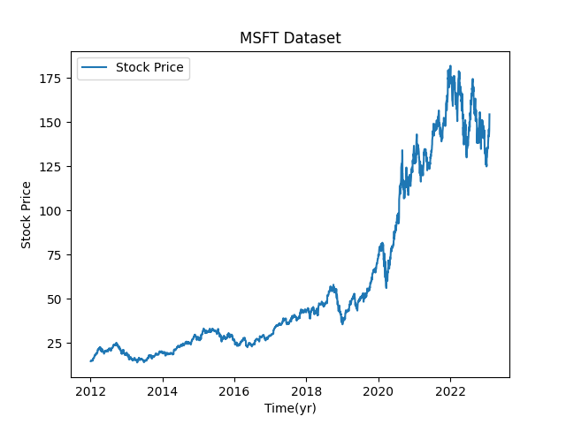

## Train, test and predicition

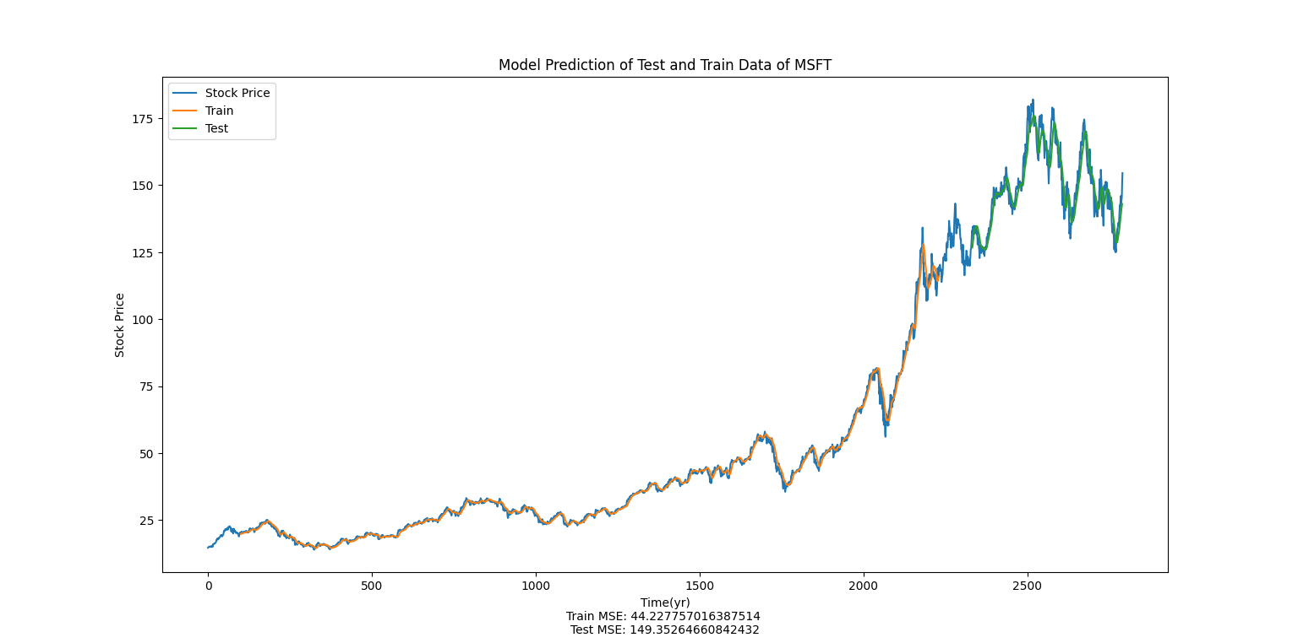

## Implementation of Stacked LSTM Model:

2

## Model:

We have trained and tested our model on four stocks that are Apple, Google, Microsoft, Amazon. We have set batch size to 64 and epochs were 10 and window size of 100.

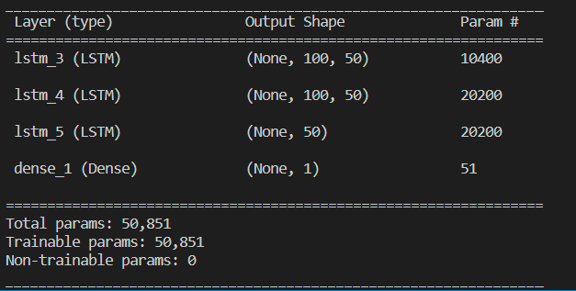

## AAPL:

## Dataset



## Train, test and prediction

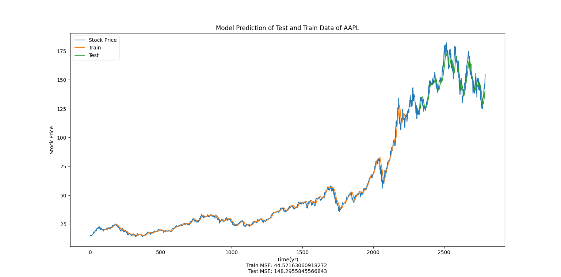

## GOOG:

## Dataset



## Train, test and predicition

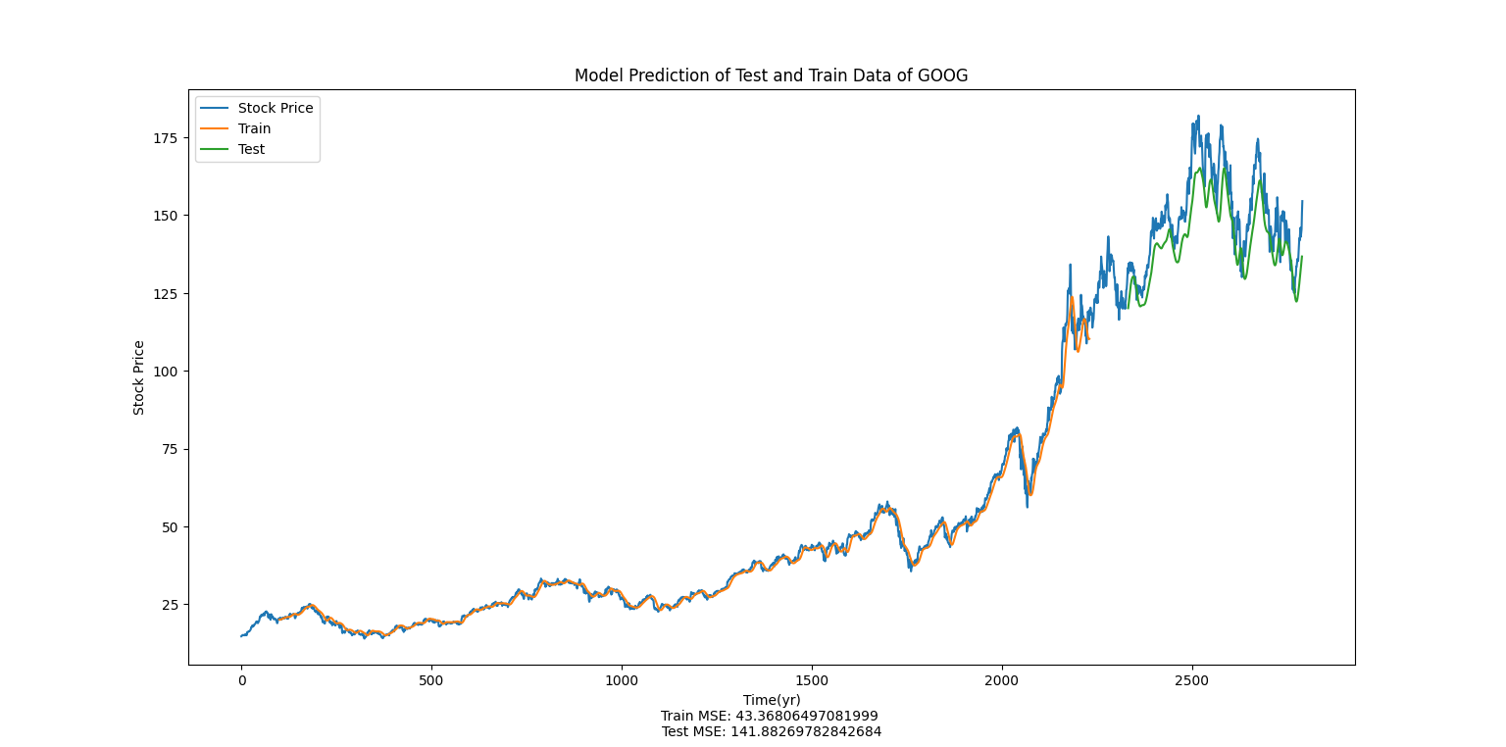

## AMZN:

## Dataset



## Train, test and predicion

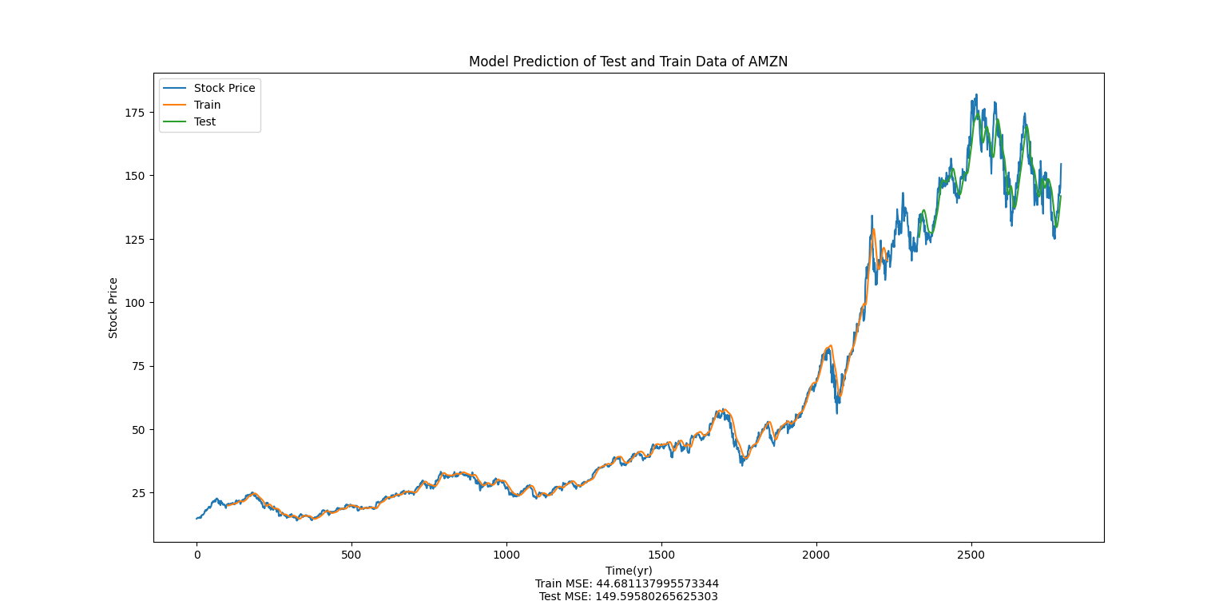

## MSFT:

## Dataset



## Train, test and predicition

